**Internet Routes and**

**Measure of Round Trip Times**

Lab 4

*50.005 Computer System Engineering*

***Due: 01 Apr 08:30 AM (Week 10)***

Overview

Learning objectives

Preparation

Submission

Part 1: Measurement of round trip times using ping

Round trip times

Unanswered pings

Part 2: Understanding Internet routes using traceroute

Route asymmetries

# Overview

In this lab exercise, you will learn how to use ping and traceroute to measure round trip times and find network routes.

# Learning objectives

At the end of this lab exercise, you should be able to:

* ● Understand how the ping and traceroute utilities work.
* ● Use the ping utility to measure network round trip times.
* ● Use the traceroute utility to find network routes.
* ● Observe and understand the effects of varying packet sizes on delays experienced.

# Preparation

You will need ping and traceroute to be installed on your OS. Most **Ubuntu** / **MacOS** installations should already include ping by default. You can install traceroute by running “sudo apt-get install traceroute” from the command line.

# Submission

* **The total points for this lab is 35**
* Export this handout and fill in your answers in the blanks denoted in **blue**
* Export as pdf and **ZIP** it (not rar, or any other compression algorithm)
* **Upload** to @csesubmitbot telegram bot using the command /submitlab4
* **CHECK** your submission by using the command /checksubmission

# Part 1: Measurement of round trip times using ping

The ping utility is one of the most widely-used network utilities. It enables you to measure the time that it takes for a packet to travel through the Internet to a remote host and back.

The ping utility works by sending a short message, known as an *echo-request*, to a remote host using the Internet Control Message Protocol (ICMP). When a host that supports ICMP receives an echo-request message, it replies by sending an echo-response message back to the originating host.

In the first part of this lab exercise, you will use the ping utility to send echo requests to a number of different hosts. In many of the exercises, you will be referring to hosts using their DNS names rather than their IP addresses. For more information about ping, you can look up its manual page by running “man ping” from the command line.

## Round trip times

Use ping to send 10 packets to each of the following hosts. Each packet should have a size of 56 bytes, and there should be an interval of 5 seconds between each packet sent.

www.csail.mit.edu

www.berkeley.edu

www.usyd.edu.au

www.kyoto-u.ac.jp

*Note:* The size of each packet is 56 bytes by default, but you may observe that the actual size of the packet is larger than 56 bytes. You can look up the manual for ping to understand why such a discrepancy exists.

**Question 1 [4pt] :** For each host, record the percentage of packets sent that resulted in a successful response. Record also the minimum, average, and maximum round trip times for the packets that resulted in a response.

**Your answer:**

| **Website** | **Successful Percentage %** | **Min RTT** | **Average RTT** | **Max RTT** |
| --- | --- | --- | --- | --- |
| www.csail.mit.edu | **100** | **19.766** | **72.077** | **124.293** |
| www.berkeley.edu | **100** | **201.680** | **201.953** | **202.220** |
| www.usyd.edu.au | **100** | **206.085** | **206.629** | **208.900** |
| www.kyoto-u.ac.jp | **100** | **90.359** | **112.008** | **134.076** |

**Question 2 [4pt]:** Describe and explain the differences in the minimum round trip time to each of these hosts.

**Your answer: The round trip times depend on the respective nodal delays, which are affected by the four factors: processing delay, queueing delay, transmission delay, and propagation delay. As the routing to and from each of the destinations are different, different routers and links are used so there is a difference in distance and number of hops. So, the propagation delay might be the biggest factor that accounts for the differences in the minimum round trip times. As** [**www.csail.mit.edu**](http://www.csail.mit.edu) **has the smallest minimum round trip time, MIT could have its own content provider network which carries traffic to and from its own servers.**

**Question 3 [4pt]:** Repeat the exercise using packet sizes of 56, 512 and 1024 bytes. Record the minimum, average, and maximum round trip times for each of the packet sizes. Why are the minimum round-trip times to the same hosts different when using 56, 512, and 1024–byte packets?

**Your answer:**

| Website | Packet Size | Successful Percentage % | Min RTT | Average RTT | Max RTT |
| --- | --- | --- | --- | --- | --- |
| www.csail.mit.edu | 56 | **100** | **54.815** | **104.718** | **153.102** |
| 512 | **100** | **66.403** | **111.864** | **154.582** |
| 1024 | **100** | **57.341** | **115.621** | **166.585** |
| www.berkeley.edu | 56 | **100** | **201.841** | **202.075** | **202.812** |
| 512 | **100** | **202.012** | **202.959** | **203.908** |
| 1024 | **100** | **201.854** | **202.994** | **204.409** |
| www.usyd.edu.au | 56 | **100** | **206.167** | **206.390** | **206.705** |
| 512 | **100** | **206.804** | **207.725** | **208.918** |
| 1024 | **100** | **207.105** | **208.101** | **208.873** |
| www.kyoto-u.ac.jp | 56 | **100** | **86.611** | **125.823** | **154.863** |
| 512 | **100** | **114.149** | **133.403** | **153.592** |
| 1024 | **100** | **115.764** | **133.514** | **151.473** |

**When the packet size is different, the transmission delay will be affected. The greater the packet size, the higher the transmission delay, hence the round trip time will be greater. Despite the increase of transmission delay, it is a minor factor compared to the fluctuation in propagation delay, so the difference in round trip time is not significant.**

## Unanswered pings

Use ping to send 100 packets to the following host. Each packet should have a size of 56 bytes, and there should be an interval of 5 seconds between each packet sent.

www.wits.ac.za

**Question 4 [8pt]:** Record the **percentage** of the packets sent that resulted in a **successful response** for each host. What are some possible **reasons** why you may not have received a response? (Be sure to check the host in a web browser).

**Your answer: 0% as these are the possible reasons:   
- the web server might have a firewall set up to block everything except the port traffic for the services offered, or  
- the web server does not exist, or  
- the computer could not establish a connection to the host.  
The first stated reason could be the reason as the URL on a web browser allows the page to load. This means the host is alive and connection has been established.**

# Part 2: Understanding Internet routes using traceroute

The traceroute utility is another useful network utility. It enables you to trace the route taken by a packet from your machine to a remote host.

Here is an example of the output produced when traceroute is used to trace the route taken by a packet to www.mit.edu.

traceroute to www.mit.edu (118.215.81.86), 30 hops max, 60 byte pack-

ets

1 192.168.9.2 (192.168.9.2) 0.221 ms 0.193 ms 0.107 ms

2 10.12.0.1 (10.12.0.1) 3.363 ms 2.555 ms 3.253 ms

3 172.16.1.106 (172.16.1.106) 3.072 ms 3.416 ms 3.418 ms

4 172.16.1.210 (172.16.1.210) 4.977 ms 4.712 ms 4.921 ms

5 192.168.22.27 (192.168.22.27) 4.806 ms 6.521 ms 6.451 ms

6 103.24.77.1 (103.24.77.1) 7.172 ms 3.590 ms 3.187 ms

7 201.210-193-8.qala.com.sg (210.193.8.201) 4.312 ms 9.056 ms 7.870 ms

8 137.203-211-158.unknown.qala.com.sg (203.211.158.137) 8.904 ms 6.690 ms 6.555 ms

9 213.203-211-158.unknown.qala.com.sg (203.211.158.213) 7.710 ms 5.423 ms 5.193 ms

10 203.116.10.125 (203.116.10.125) 6.783 ms 6.705 ms 6.440 ms

Each line in the output begins with a host on the route from your computer to www.mit.edu, followed by the round-trip times for 3 packets sent to that host. For more information about traceroute, you can look up its manual page by running “man traceroute” from the com- mand line.

**Question 5 [5pt]:** Explain how traceroute discovers a path to a remote host. (*Hint:* The traceroute manual will be helpful for answering this question.)

**Your answer: Traceroute tracks the route packets taken from an IP network on their way to the remote host. It utilizes the IP protocol's time to live (TTL) field and attempts to elicit an ICMP TIME_EXCEEDED response from each gateway along the path to the host. It starts by sending 3 packets that will reach router i (reached after i hops) on path towards destination (the number i is unknown in the beginning, starts from 1 and is gradually increased by 1, maximum number of hops is set to be certain number), and the router i will return the packets to the sender. The round trip time (to router i and back) is then measured and reflected for each packet. This continues until the destination is reached or the maximum number of hops is reached.**

## Route asymmetries

In this exercise, you will run traceroute in two opposite directions. First, you will run traceroute on a remote host to see the route taken to your network. You will also run traceroute from your computer to see the route taken to that host.

**Step 1**: Find out your computer’s public IP address. (Hint: You can use a website like <http://www.whatismypublicip.com/>, or search for “what is my ip” using Google’s search engine.)

**Step 2:** Visit<https://www.uptrends.com/tools/traceroute> in your web browser. Enter your computer’s public IP address, select the “from Location” and click “Start Test” to start a traceroute to your computer. Follow the steps shown below for at least three locations namely: New York, Amsterdam, Tokyo.

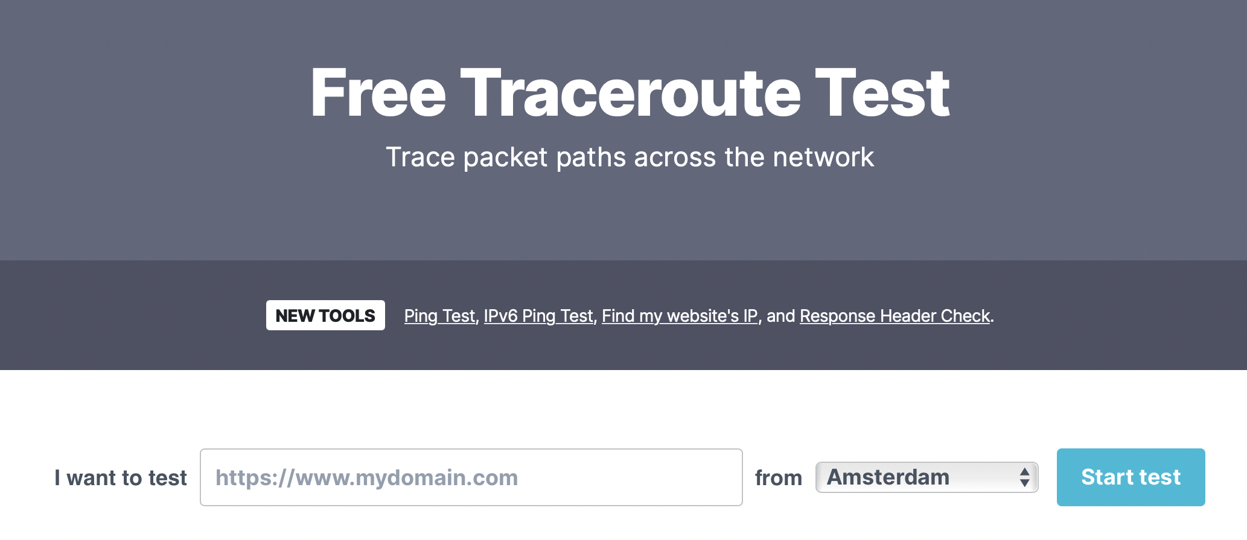

**Step 3:** After traceroute finishes running, you should be able to view the route taken from specified location to your network. Record the IP address of the first hop, which will be used in the next step.

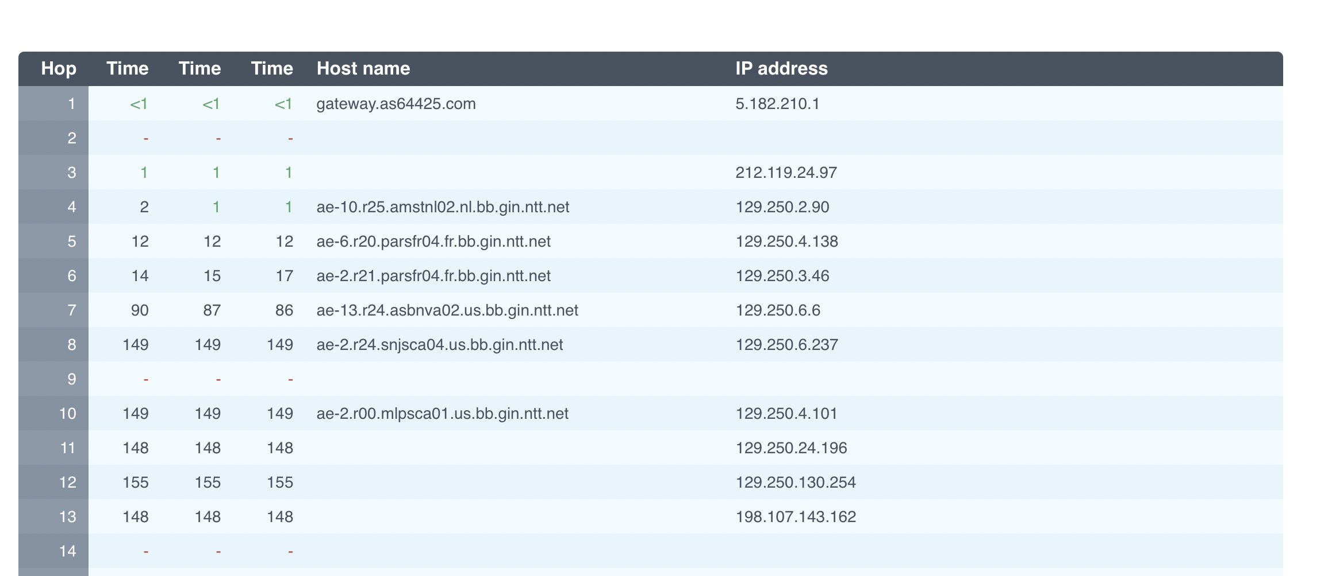

**Step 4:** On your computer, run traceroute using the IP address recorded in the previous step as the remote destination.

$ traceroute *<ip address from step 3>*

**Question 6 [5pt]:** Record the output of traceroute when run in both directions above. **Paste it as screenshots at the end of this document.**

**New York  
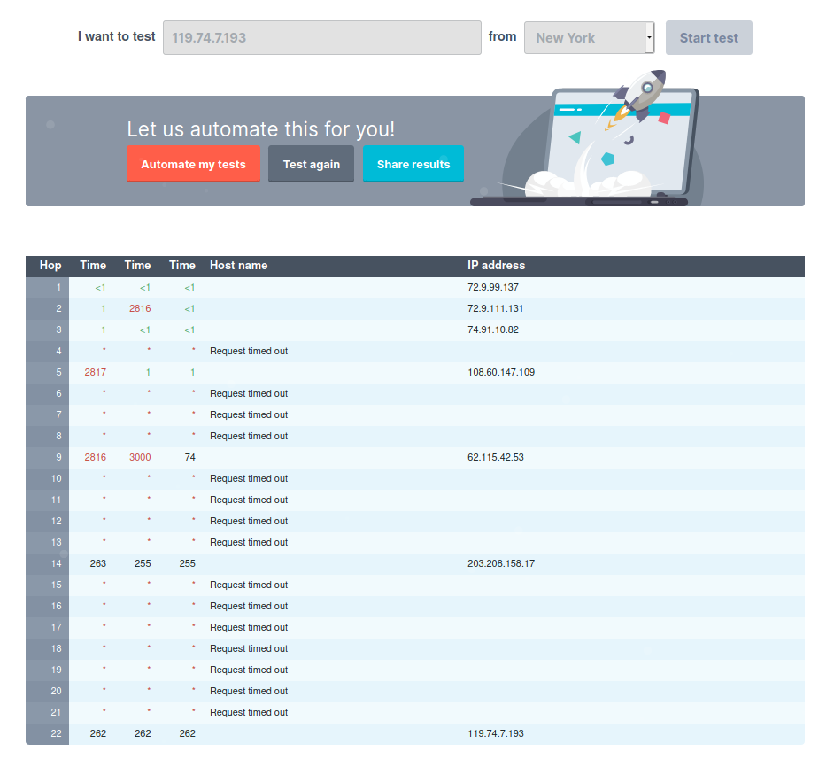  
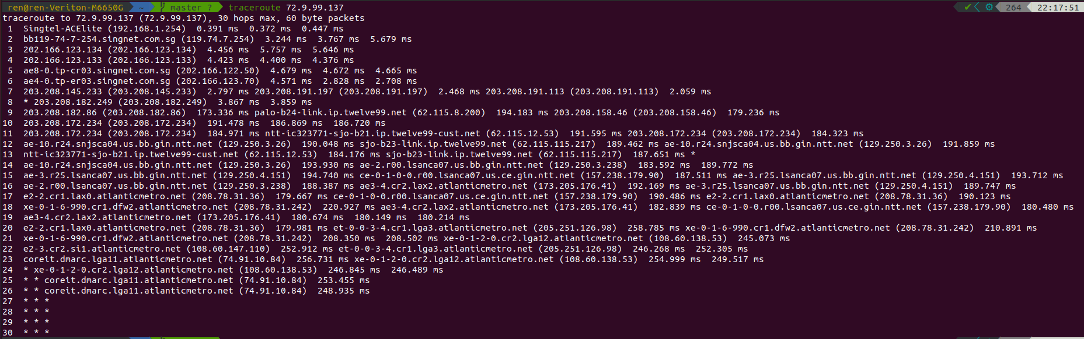**

**Amsterdam  
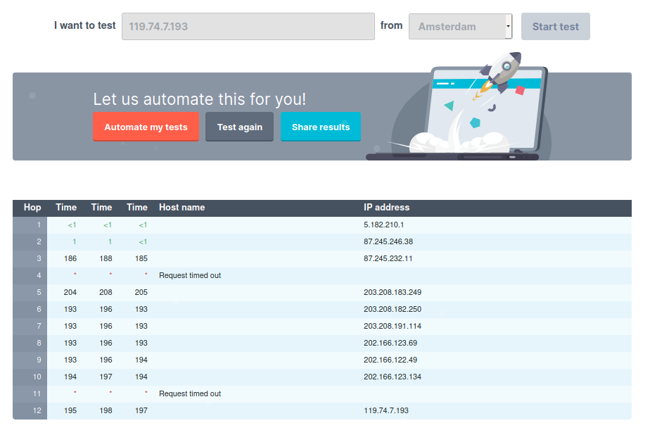  
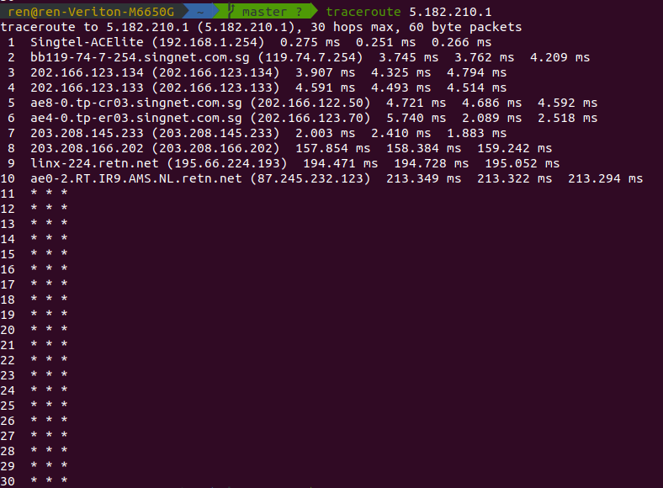  
  
Tokyo  
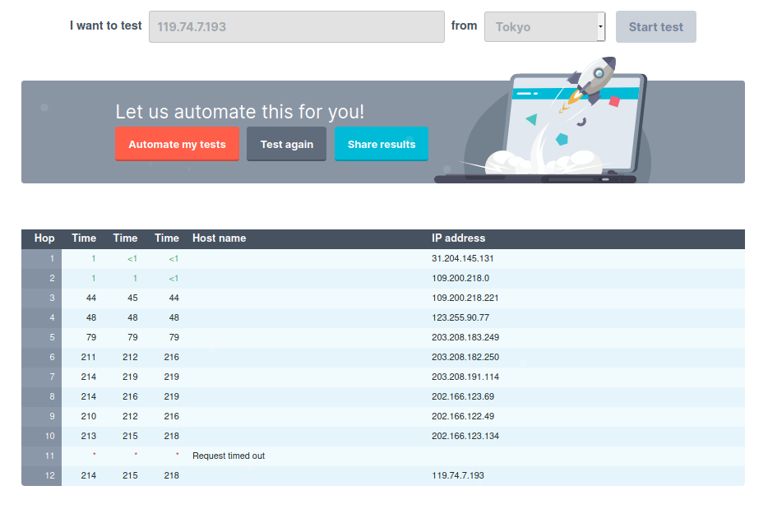  
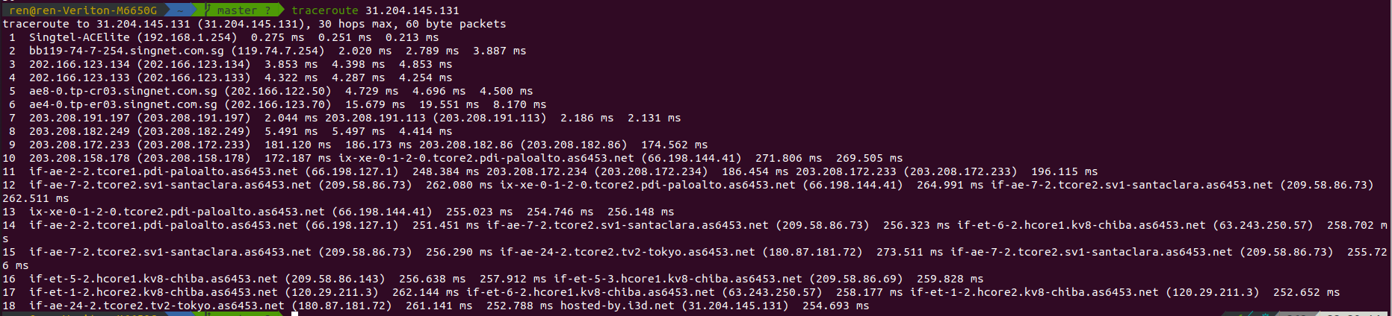**

**Question 7 [5pt]:** Describe anything unusual you might observe about the output. Are the same routers traversed in both directions? If no, why might this be the case?

**Your answer: Different routers traversed in each direction as the source will pick a suitable router for the subsequent hop. Since the sources are different from each direction so the chosen router from the pool of i number of hops and sequence of routers are different.**